**Silver State Brigade**

**Cadet and Junior Leader of the Semester and Year Board**

**Study Guide**

(12 August 2019)

**General Junior ROTC Knowledge**

1. Name the congressional act that launched the JROTC program.

Answer: The National Defense Act of 1916

1. What year was Public Law 88-647, known as the Reserve Officer Training Corps Vitalization Act passed? This Act directed the secretaries of each branch of the service to establish and maintain Junior ROTC units.

Answer: 1964.

1. What do the letters JROTC stand for?

Answer: Junior Reserve Officers Training Corps.

1. What is the mission of JROTC?

Answer: “To motivate young people to be better citizens”.

1. What is the title of the instructor who is in charge of a school’s JROTC unit?

Answer: Army = Senior Army Instructor

Navy = Senior Naval Science Instructor

Air Force = Senior Aerospace Science Instructor

1. What uniform is worn to the Military Ball and/or other formal type function?

Answer: Army = Class A (Army Blue)

Navy = Service Dress Blues

Air Force = Service Dress

1. What is the minimum cadet enrollment required for a school to have a JROTC program?

Answer: At least 100 cadets or 10% of the student body, whichever is less.

1. In what year was Public Law 93-165 passed allowing females to be counted towards the enrollment requirement for JROTC?

Answer: 1973.

1. What does the acronym NCO stand for?

Answer: Non-commissioned Officer.

1. The “position of honor” where the senior ranking individual always sits or walks is where?

Answer: On the right.

**Leadership**

1. Define leadership.

Answer: The ability to influence others in order to reach a goal.

1. Define teamwork.

Answer: The cooperative effort on the part of a number of people working together to achieve a goal.

1. Define “Integrity” as a leadership trait.

Answer: Integrity is the quality or state of being of sound moral principle; uprightness, honesty, and sincerity.

1. Define “Loyalty” as a leadership trait.

Answer: Loyalty is faithfulness or allegiance to superiors, peers, and subordinates.

1. Define “Decisiveness” as a leadership trait.

Answer: Decisiveness is a willingness to act.

1. Define “Selflessness” or “Unselfishness” as a leadership trait.

Answer: Selflessness or unselfishness is the ability to sacrifice personal needs and wants for a greater cause.

1. Define “Delegation”

Answer: Delegation is assigning responsibility and authority to someone in order

to complete a clearly defined task while you retain ultimate responsibility for its

success.

1. Define “Authority”

Answer: Authority is often used interchangeably with power. The power most

often comes from the duties and responsibilities delegated to a position

holder in a bureaucratic structure.

1. Define “Power”.

Answer: The possession of authority, control, or influence by which a person

influences the actions of others, either by direct authority or by some

other, more intangible means.

**Drill and Ceremonies**

1. What are the two parts of a command?

Answer: The preparatory command and the command of execution.

1. What foot do you call “To the Rear, March” or “Rear, March” on?

Answer: The right foot.

1. On which foot can you give the command “Halt” on?

Answer: Either.

1. What is normal cadence?

Answer: Army & Navy = 120 steps per minute.

Air Force = 100 steps per minute.

1. How many inches are there in a normal step in marching?

Answer: Army & Navy = 30 inches.

Air Force = 24 inches.

1. At what position are you allowed to speak while in formation?

Answer: At the position of “Rest”.

1. What command gets all the cadets to salute?

Answer: The command of “Present Arms”.

1. What is the rate of march for “Quick Time”?

Answer: Army & Navy = 120 steps per minute.

Air Force = 100 to 120 steps per minute.

1. What is the rate of march for “Double Time”?

Answer: 180 steps per minute.

1. What command(s) can be given from the position of “Parade, Rest”?

Answer: Navy & Air Force = “Attention”.

Army = “Attention”, “Stand At Ease”, “At Ease”, or “Rest”.

1. On what foot is the command of “Counter Column” given when marching?

Answer: The left foot

**First Aid & Health**

1. What is First Aid?

Answer: Immediate temporary care given to an injured or ill person until he or she can get professional help.

1. What do the letters CPR stand for and what is it used for?

Answer: Cardiopulmonary Resuscitation is a first aid procedure that combines rescue breaths with chest compressions to restore breathing and circulation.

1. Describe “Shock”.

Answer: “Shock” is a life-threatening condition in which the circulatory system fails to deliver enough blood to vital tissues and organs.

1. What is the “Heimlich Maneuver” (abdominal thrusts) used for?

Answer: To clear a blocked airway.

1. Describe what is meant by “universal precautions”.

Answer: “Universal precautions” are actions taken to prevent the spread of disease by treating all blood as if it were contaminated.

1. Name two of the six types of nutrients.

Answer: Carbohydrates, Proteins, Fats, Vitamins, Minerals, and Water.

1. What are the three types of bleeding?

Answer: Capillary, Venous, and Arterial

1. What are the four-lifesaving steps?

Answer: 1. Clear the airway and restore breathing

2. Stop the Bleeding

3. Treat and dress the wounds to prevent infection

4. Prevent Shock

1. What is the ratio of chest compressions to rescue breaths when performing adult CPR?

Answer: 30 compressions to two breaths

**Chain of Command**

1. What elected federal government office does the “Commander-In-Chief” of our armed forces occupy.

Answer: The Office of the President of the United States.

1. Who is the Secretary of Defense?

Answer: The Honorable James N. Mattis.

1. Who is the (ask specific service appropriate) Army Chief of Staff, or Chief of Naval Operations, or Air Force Chief of Staff?

Answer: Navy = Admiral John Richardson

Army = General Mark A. Miley

Air Force = General David L. Goldfein

1. Who is the Chairman of the Joint Chiefs of Staff?

Answer: General Joseph F. Dunford Jr.

1. What are the three branches of the federal government?

Answer: Executive, legislative, and judicial.

1. Is the Chief of the National Guard Bureau a member of the Joint Chiefs of Staff?

Answer: Yes.

1. What are the three branches of the United States military and what is their order of formation?

Answer: United States Army, United States Navy, and United States Air Force.

1. What branch of the United States military is the United States Marine Corps actually a part of?

Answer: The United States Navy.

1. Who is the Commander in Chief of the Military?

Answer: President Donald J. Trump

**Military Customs and Courtesies**

1. Who wrote the “Star-Spangled Banner”?

Answer: Francis Scott Key.

1. What do the 13 stripes on the United States flag represent?

Answer: The 13 original colonies.

1. Explain the "position of honor."

Answer: A military courtesy of keeping people of senior rank or status to your right while walking or sitting.

1. The signal for the start of the official duty day is called what?

Answer: Reveille.

1. When may the United States Flag be flown at night?

Answer: When it is properly lit.

1. When may the United States Flag be flown upside down?

Answer: In times of distress.

1. When does a cadet end their salute to a superior?

Answer: When the salute is acknowledged.

1. What do the colors on the United States Flag represent?

Answer: Blue = vigilance, perseverance, and justice.

Red = hardiness and valor.

White = purity and innocence.

1. When is it appropriate to call a room to attention?

Answer: When an officer enters the office for the first time each day.

1. How many stripes were on the United States Flag that flew at Fort McHenry at the time Francis Scott Key wrote our National Anthem and what did each stripe represent?

Answer: Fifteen, and each stripe represented one of the fifteen colonies.

1. Describe the position of Honor while walking with a superior.

Answer: The subordinate should walk on the left side and one-step to the rear of

a superior.

1. What is the proper place of Honor while walking?

Answer: When walking, a junior officer does not precede a senior officer. The

lower ranking member should give the superior walking room, allowing

the senior officer to stay on the right. The junior officer should stay in

step with the senior officer.

1. What is the proper place of Honor while riding in a Military Vehicle?

Answer: When officers of varied grades ride in a staff car or similar military

vehicle, the senior officer sits in the right rear position.

**United States Military History and Civics**

1. Who were our primary antagonists during World War I?

Answer: Germany, Austria, and Hungary?

1. Who were our primary antagonists during World War II?

Answer: Germany, Italy, and Japan.

1. What happened on December 7th, 1941 in Hawaii?

Answer: The Japanese attacked Pearl Harbor.

1. Who was the Commander of the Revolutionary Army?

Answer: General George Washington.

1. What war accounted for the most American deaths?

Answer: The Civil War of the United States.

1. What war did we fight in during the 1960’s and 1970’s?

Answer: The Vietnam War.

1. What country did the United States and its’ allies fight in the 1st Gulf War?

Answer: Iraq.

1. What are the first 10 Amendments of the United States Constitution known as?

Answer: The Bill of Rights.

1. Which amendment guarantees the “Freedom of Speech”?

Answer: The First Amendment.

1. At what age is a United States Citizen first allowed to vote?

Answer: At 18 years of age.

1. Which amendment guarantees the “Right to Bear Arms”?

Answer: The Second Amendment.

1. Which amendment is the only amendment to override another amendment?

Answer: The 21st Amendment (overrode the 18th Amendment that dealt with

prohibition).

1. What are the two ways individuals may become American citizens?

Answer: By being born or naturalized in the United States.

1. Define “Naturalization” as it applies to becoming an American citizen?

Answer: The legal process by which foreigners can choose to become American citizens.

1. Who was the Prussian officer credited with turning the continental Army around during the Revolutionary War?

Answer: Frederick Von Stueben

1. The "Star Spangled Banner" was written during the British bombardment of what military installation?

Answer: Fort McHenry

1. What military branch of service is the senior service?

Answer: Army

1. What department does the US Coast Guard come under?

Answer: Department of Homeland Security

**Navy JROTC Ranks and Rates**

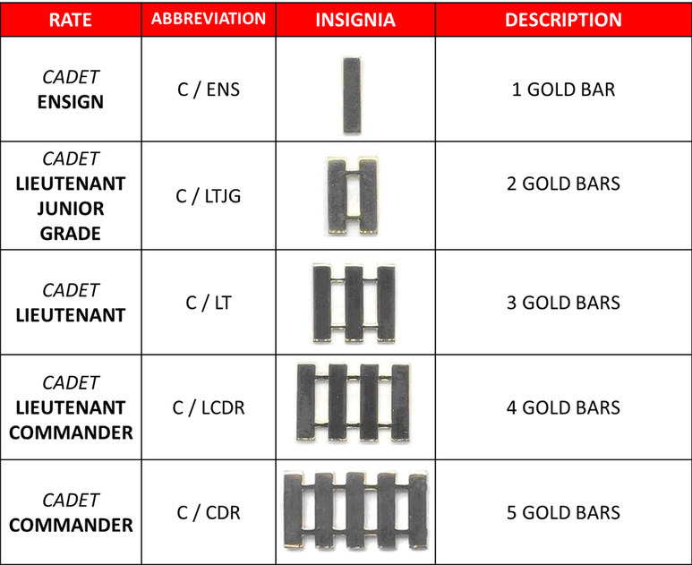

**[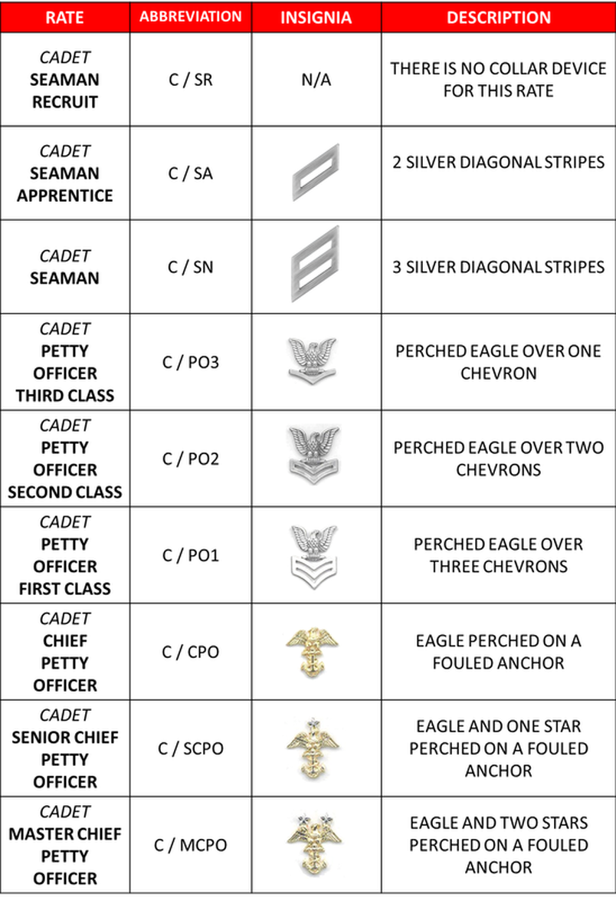](https://sites.google.com/a/navyjrotc.us/njrotc-novahs/home/academic-links/ranks-rates/NJRTOC%20enlisted%20ranks%20chart.png?attredirects=0)**

**Army JROTC Ranks**

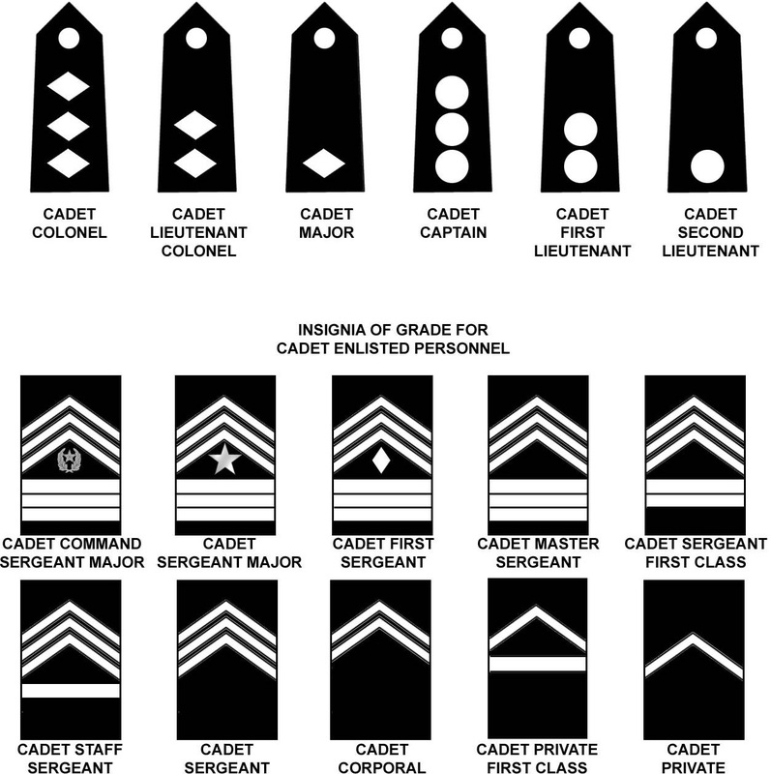

[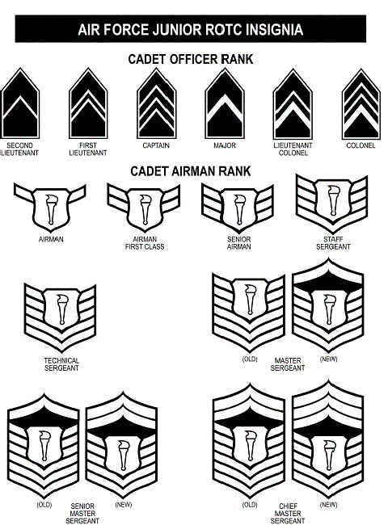](https://www.google.com/url?sa=i&rct=j&q=&esrc=s&source=images&cd=&cad=rja&uact=8&ved=2ahUKEwiUnp_oze3cAhXnx1QKHeztABEQjRx6BAgBEAU&url=https://www.pinterest.com/pin/556124253958315251/&psig=AOvVaw0PaRvNV_qX-98-ALrca3dN&ust=1534372674945210)